

Project Name: E-Worker Hiring System

Branch e-DAC SEPT 2021

Documentation On

**“E-Worker Hiring System”**

PG-DAC SEPT 2021

**Guided By: Mrs. Snehal Somvanshi .**

Submitted By :

**Group No: 13**

* **Harshada Nandawate 210943020028**
* **Jayesh Patil 210943020031**
* **Pratik Kale 210943020032**
* **Komal Dhere 210943020039**

**Table of Contents**

**1. Introduction 4**

1.1 Document Purpose **4**

1.2 Project Background **4**

1.3 Goals of the Project **4**

**2. Business Requirements Overview**…………………………………………………………**5**

**3. Functional Requirements** **6**

3.1 Worker Module **6**

3.2 Client Module **6**

3.3 Admin Module **6**

4. **Non-Functional Requirement………………………………………………………………7**

**5. Use Case Diagram 8**

5.1 Admin **9**

5.2 Worker **10**

5.3 Client **11**

**6. Database Design 12**

6.1 Admin **12**

6.2 Worker **12**

6.3 Client……………………………………………………………………………**…….13**

**7. E-R Diagram………………………………………………………………………………………14**

**8. Snapshots 15**

**9. Conclusion 20**

**List of Figures**

**Use Case Diagrams 17**

Fig 1 Admin 8

Fig 2 Worker 9

Fig 3 Client 10

Fig 4 ER Diagram 14

# 1. Introduction

# **Document Purpose**

# This document communicates the business requirements and scope for developing E-Worker Hiring System. The scope of this document is to define the functional and non-functional requirements, business rules and other constraints requirements.

# **Project Background**

# There are many existing portals available for hiring employees like naukari.com, Monster etc. where there is no single portal for Workers. In current scenario, Workers communicate with agent for the employment and have to pay commission to the agent due to this Workers do not get fully financial benefit. In current Worker hiring process, Worker may lose employment opportunity due to delay in response to the agent. Agent faces shortage of Workers and he couldn’t fullfill client’s requirement. Moreover, existing system is much tedious and time-consuming.

# **Goals of the project**

# E-Worker Hiring automated system provides a portal for Worker employment. Hiring process is controlled by administrator. E-Worker Hiring System will play key role in minimizing manual work and errors as well as eliminating Worker agents in this entire cycle. It will save much time as well as reduce losses incurred traditional hiring system. This recruiting system will end the search for web based Worker hiring. Each Worker can be identified by the organizational unique id. Workers get a chance to quickly react to new request and have employment. In initial phase, the system will be only for specific region.

# **Customers**

* + Client who wants Workers.
  + Worker who wants employment.

# 2. Business Requirements Overview

* E-Worker Hiring System is the public web application.
* E-Worker Hiring System will be opened to the global, but in first phase, the main target is in the city.
* There are mainly two types of user. One is the client and other is Worker.
* In E-Worker Hiring System, client can reach directly to the available Workers.
* E-Worker Hiring System is maintained by administrator.

# 3. Functional Requirements Overview

E-Worker Hiring System consists of four modules described as below.

1. Client Module
2. Worker Module
3. Admin Module
4. Message Acknowledgement Module

# 

# **3.1 Client Module**

* Client can register and create his own account.
* E-Worker Hiring System provides feature to put client’s requirement on website.
* Client can select number of Workers as per the requirement.
* On daily basis, client can browse wages per Worker .
* E-Worker system provides replacement feature for Workers in case of any emergency or accidental situations.

# **3.2 Worker Module**

* Worker can register and create his own account.
* Worker can accept or reject request of clients as per his availability.

# 

# **3.3 Admin Module**

* E-Worker Hiring System is controlled by administrator.
* Admin have rights to authorize users.

* Admin can see all transaction history.
* Admin decide Workers wages as per the market research.

# **3.4 Message Acknowledgement Module**

* Message Acknowledgement Module should provide the employment details to respective Worker and confirmation of hiring to client through email.

# 4. Non-functional Requirements

* The website should use professional design, look and feel and color scheme.
* Users will have no limitations for accessing the application through Internet. The portal being an internet application, it is difficult specify exact number of visitor or users. Hence, we will target the system to support between 5 and 10 million users on launch of phase 1.
* Being a public website, the site must follow general usability guidelines for menus, navigation, colors, links and other actions provided on the screens.
* The system should be designed in such a manner that user will be able to complete tasks in minimum number of steps.

## 5. Use-Case Diagram

**5.1 Admin:**

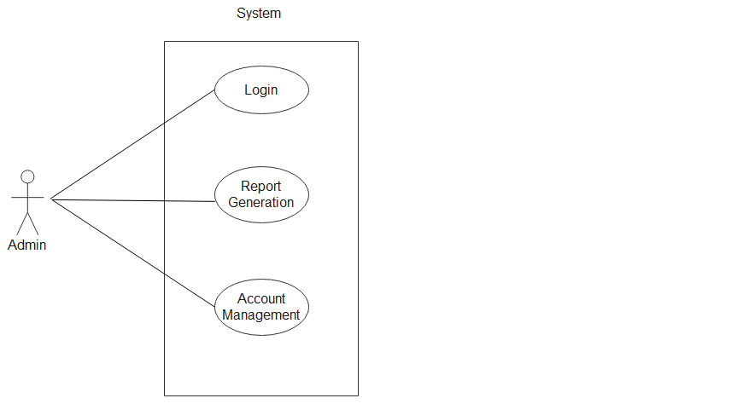 **Fig. Use-Case Diagram for Admin**

## 5.2 Worker:

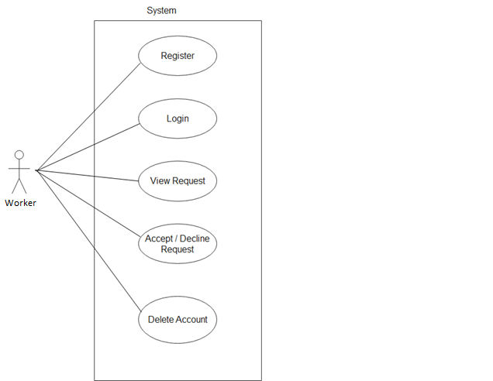

**Fig. Use-Case Diagram for Worker**

**5.3 Client:**

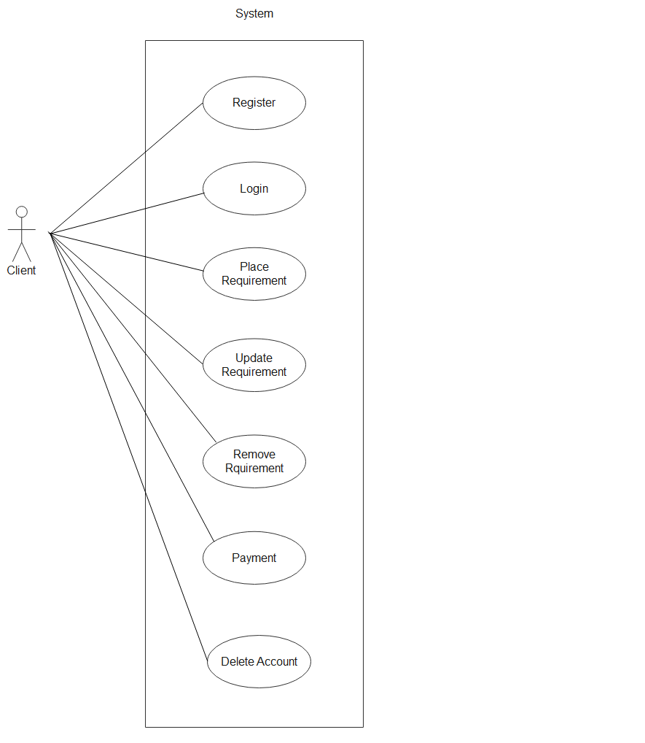

**Fig. Use-Case Diagram for Client**

**6. Database Design:**

**6.1 User**

|  |  |  |  |  |  |
| --- | --- | --- | --- | --- | --- |
| **Field** | **Type** | **Null?** | **Key** | **Default** | **Description** |
| user_id | Integer | No | Primary key | AutoIncrement | User ID |
| fname | Varchar(45) | Yes |  | Null | First Name |
| lname | Varchar(45) | Yes |  | Null | Last Name |
| email | Varchar(45) | Yes |  | Null | Email ID of User |
| password | Varchar(15) | Yes |  | Null | Account Password |
| contact_no | Integer | Yes |  | Null | Contact No. of User |
| Gender | Varchar(10) | Yes |  | Null | Gender Information |
| user_type | Varchar(10) | Yes |  | Null | Worker/Client |
| Address | Varchar(225) | Yes |  | Null | Address of User |

**6.2 Worker**

|  |  |  |  |  |  |
| --- | --- | --- | --- | --- | --- |
| **Field** | **Type** | **Null?** | **Key** | **Default** | **Description** |
| Worker_id | Integer | No | Primary key | AutoIncrement | Worker Id |
| user_id | Integer | Yes | Foreign key | Null | User ID is Primary key from User table |
| Worker_type | Varchar(45) | Yes |  | Null | Worker type |

**6.3 Admin**

|  |  |  |  |  |  |
| --- | --- | --- | --- | --- | --- |
| **Field** | **Type** | **Null?** | **Key** | **Default** | **Description** |
| admin_id | Integer | No | Primary key | AutoIncrement | Admin ID |
| user_id | Integer | Yes | Foreign key | Null | User ID is Primary key from User table |

**6.4 Client**

|  |  |  |  |  |  |
| --- | --- | --- | --- | --- | --- |
| **Field** | **Type** | **Null?** | **Key** | **Default** | **Description** |
| client_id | Integer | No | Primary key | AutoIncrement | Client id |
| user_id | Integer | Yes | Foreign key | Foreign key | User ID is Primary key from User table |
| client_type | Varchar(45) | Yes |  | Null | Client type |

**6.5 Employment_Details**

|  |  |  |  |  |  |
| --- | --- | --- | --- | --- | --- |
| **Field** | **Type** | **Null?** | **Key** | **Default** | **Description** |
| emp_id | Integer | No | Primary key | AutoIncrement | Employment Id |
| client_id | Integer | Yes | Foreign Key | Null | Client id is Primary key from Client table |
| no_of_Workers | Integer | Yes |  | Null | Number of Workers |
| work_days | Integer | Yes |  | Null | Expected days of employment |
| req_date | Datetime | Yes |  | Null | Request Date |
| req_status | Varchar(45) | Yes |  | Null | Accept/Decline Acknowledgement |
| Address | Varchar(225) | Yes |  | Null | Employment address |

## 

## 7. ER-Diagram:

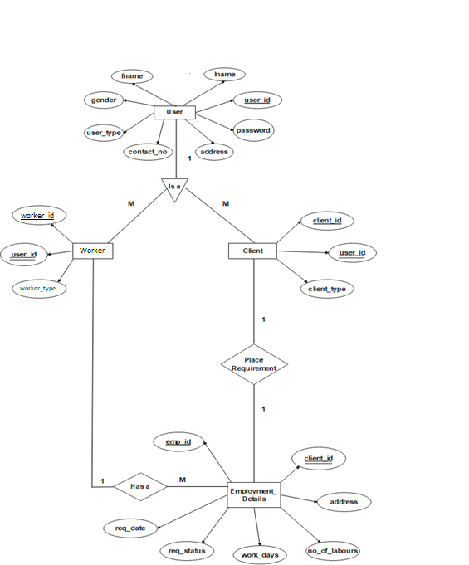

**E-R diagram shows database of E-Worker Hiring System**

**8.Snapshots:**

**8.1 Home Page:**

Following snapshot shows the home page for E-Worker Hiring System

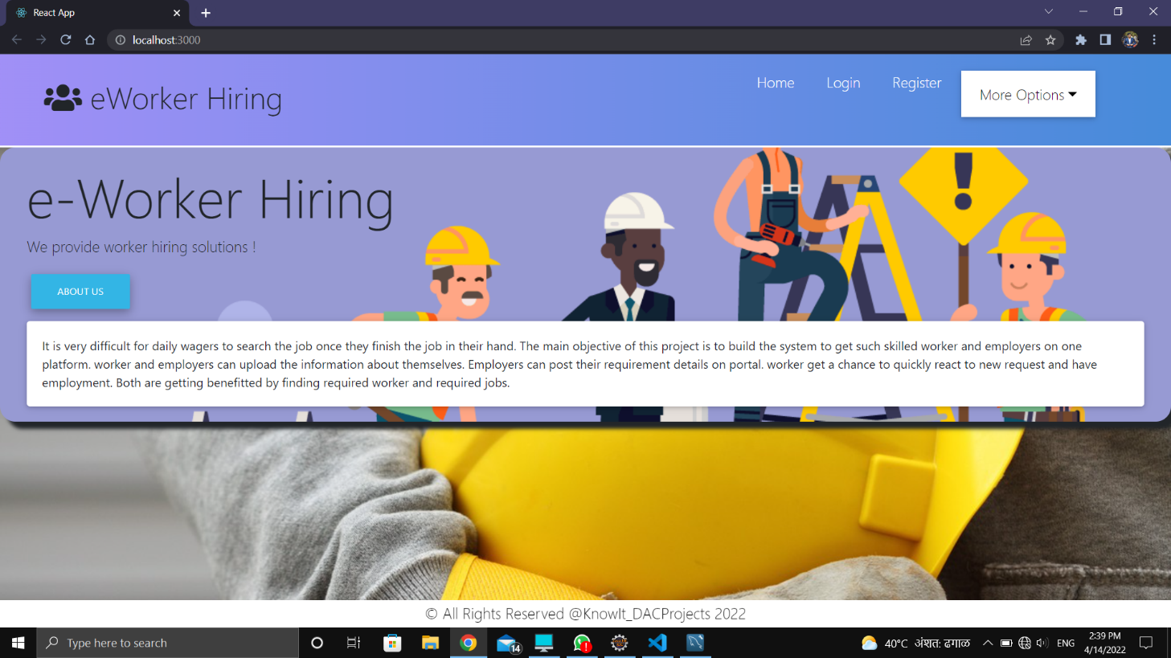

This page contains following controls

* Login Button
* Registration
* Home

## Login Button

when user fill the login user-id and password and click login button then if the information is valid then he will be redirected to respective home page , else error message will be shown to user.

## Registration link;

When user click on registration link then he will be redirect to registration page.

**8.2 User Registration**

Following snapshot shows the registration page for E-Worker Hiring System

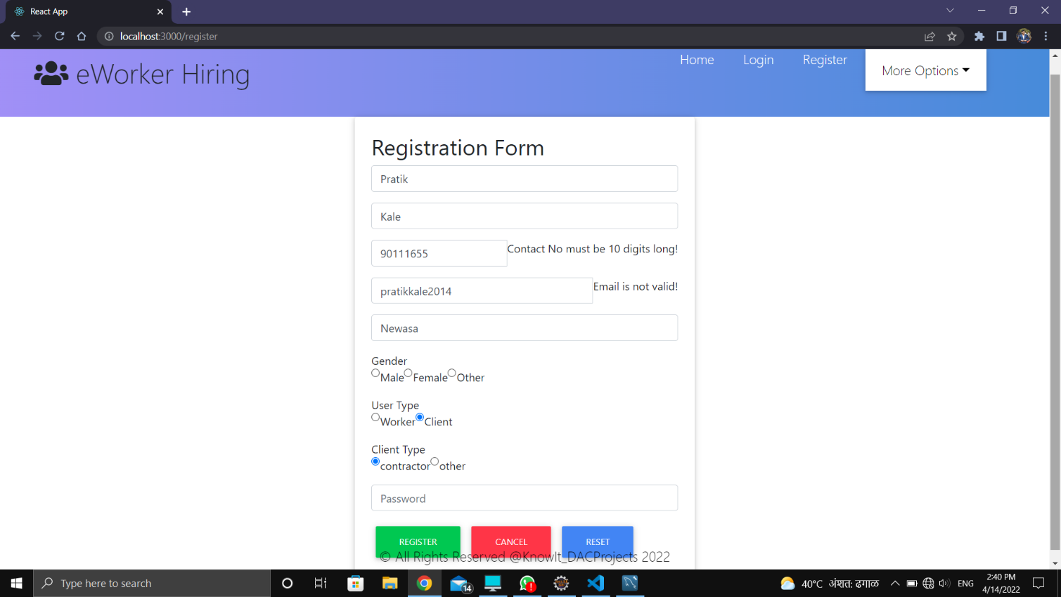

**8.3 User Login**

Following snapshot shows the User Login page for E-Worker Hiring System

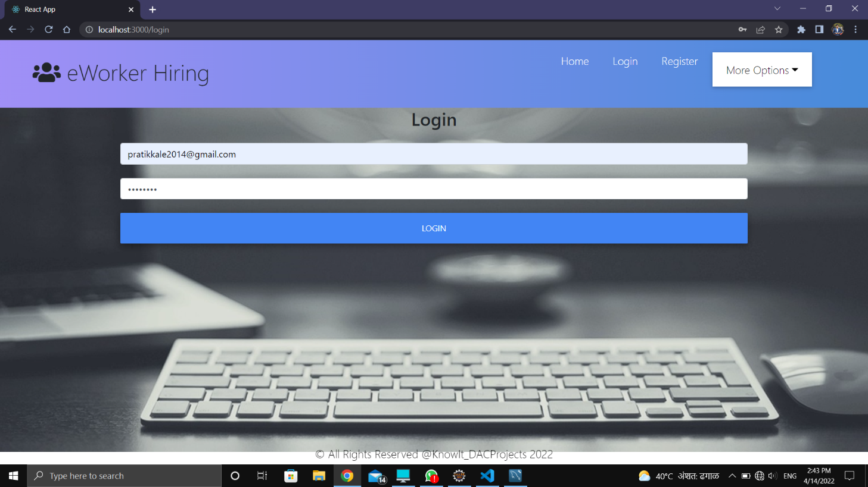

V4

**8.4 Users List**

Following snapshot shows the Users List page for E-Worker Hiring System

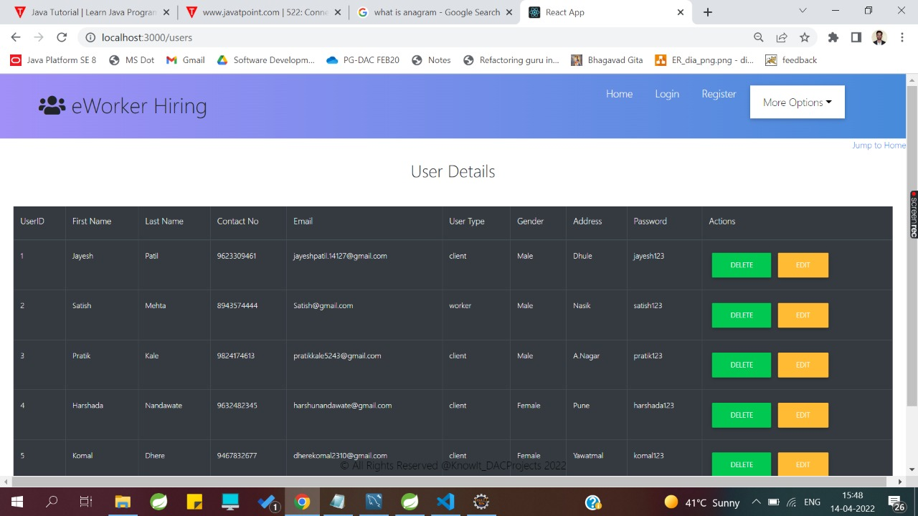

**8.5 Employment_Details List**

Following snapshot shows the Employment_Details List page for E-Worker Hiring System

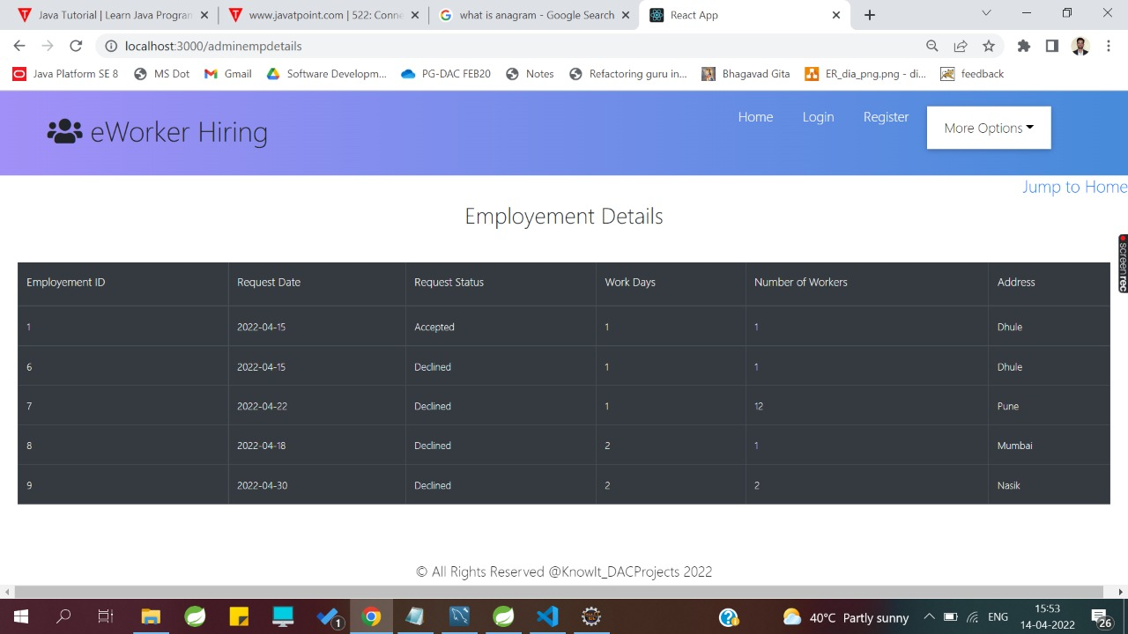

1. **CONCLUSION AND FUTURE SCOPE**

* E-Worker Hiring System helps Workers for getting employment without paying commission to the third party agents.
* Our System provides a very user-friendly platform registration system where clients can easily place their requirements and Workers who want to have employment can easily reach to clients in their region.
* E-Worker Hiring system can be implemented at global level.
* Online Payment Mode can be implemented in the system.
* Worker Replacement feature can be implemented.